BACKGROUND
The sustainable development of the building industry as well as new applications require concretes of specific properties. These concretes prove useful in terms of laboratory testing, but difficulties arise in their practical application and in behaviour prediction as they diverge from common routines, norms, and recommendations. The putting of non-traditional concretes into practice represents therefore an interdisciplinary problem. The conference will focus on the exchange of the experience of the research, preparation, testing and application of these materials.
We know that today´s non-traditional cements and concretes may become traditional tomorrow. It would be a wonderful thing if even this conference contributed its share towards this goal.

ORGANISATION OF THE conference
The conference is organised by VSB – Technical University of Ostrava – Faculty of Civil Engineering, Institute of Physics of Materials, Brno University of Technology – Faculties of Civil Engineering and Chemistry.

Topics
- Geopolymers
- Alkali-Activated Materials
- Clinker-free concrete
- Concrete with mineral and chemical admixtures
- High Performance Concrete
- Durability of non-traditional concrete
- Sustainable development
- Damage and fracture of non-traditional concrete
- Quality control of non-traditional concrete
- Construction from non-traditional concrete

Honorary Advisory panel
P.-C. Aïtcin (Canada) | A. PALOMO (Spain)
H. Y. Ghorab (Egypt) | P. Rovnaníková (Czech Republic)
I. JANOTKA (Slovakia) | M. Sanytsky (Ukraine)
P. Krivenko (Ukraine) | C. Shi (China)
W. Kurdowski (poland)

Advisory panel
H. Abdelgader (Libya) | D. Koloušek (Czech Republic)
D. S. Cheema (Australia) | M. KOMLJENOVIC (Serbia)
L. Coppola (Italy) | F. Kresta (Czech Republic)
N. DE Belie (Belgium) | i. lancellotti (Italy)
H.J.H. BroUwers (Nederland) | P. Martauz (Slovakia)
R. Čajka (Czech Republic) | I. MERTA (Austria)
R. Černý (Czech Republic) | M. Mosquet (France)
H. CIFUENTES (Spain) | D. Novák (Czech Republic)
W. DE CORTE (Belgium) | M. PALOU (Slovakia)
J. DEJA (Poland) | J. Papayianni (Greece)
J. van Deventer (Australia) | J. PROVIS (United Kingdom)
A. Duran Hererra (Mexico) | F. Puertas (Spain)
G. Ferrari (Italy) | R. Pukl (Czech Republic)
A. FERNANDEZ-Jimenez(Spain) | W. Schmidt (Germany)
H. J. feuerborn (Germany) | A. Sicakova (Slovakia)
P. HÁJEK (Czech Republic) | A. TAGNIT HAMOU (Canada)
R. Jones (Scotland) | P. Trtík (Switzerland)
H. JUSTNES (Norway) | J.L. Vítek (Czech Republic)
J. KATZER (Poland) | Y. Zhuge (Australia)

Organising Committee
Vlastimil Bílek, Zbyněk Keršner, Stanislav Seitl, Jiří BroŽovský
Hana Šimonová, Tomáš Opravil, František šoukal

VENUE / BRNO CITY
The conference will be held in Hotel Continental in Brno (https://www.continentalbrno.cz/en/). We are negotiating special conference rates in this hotel.
Brno is the second largest city in the Czech Republic and the metropolis of South Moravia. About 400.000 people live there. There are a lot of cultural and other sights.
Brno is located 200 km from Prague and 150 km from Vienna (Austria). There are international airports in the cities. A lot of express trains and buses connect these cities with Brno.

Contact address / WEB
Vlastimil Bilek
Faculty of Civil Engineering
VSB – Technical University of Ostrava
708 30 Ostrava-Poruba
Czech Republic

Tel: +420 602 744 586
E-mail: vlastimil.bilek@vsb.cz

https://www.fce.vutbr.cz/stm/fracture/symposium2023/

Call for papers
Prospective authors or participants are invited to submit an abstract of about 100–200 words no later than 31st January 2023 on e-mail address vlastimil.bilek@vsb.cz
All abstracts must include the full postal and mailing address of the corresponding author. Please, designate the number of topic and the type of presentation – poster or oral. We expect at least one (co)author of each submitted paper to be present at the conference.

Important dates
October 30, 2022 Call for papers
February 19, 2023 Deadline for abstracts
February 28, 2023 Notification of acceptance
April 30, 2023 Submission of papers
June 25–28, 2023 Conference held in Brno

Registration fees and proceedings
Selected papers will be published after review in Scopus or WoS indexed publication.
Conference fee: 550 EUR
PhD students: 300 EUR
Publication in Scopus 180 EUR

7th International Conference
Non-traditional Cement and Concrete

NTCC 2023

June 25-28, 2023

Brno, Czech Republic

organised by

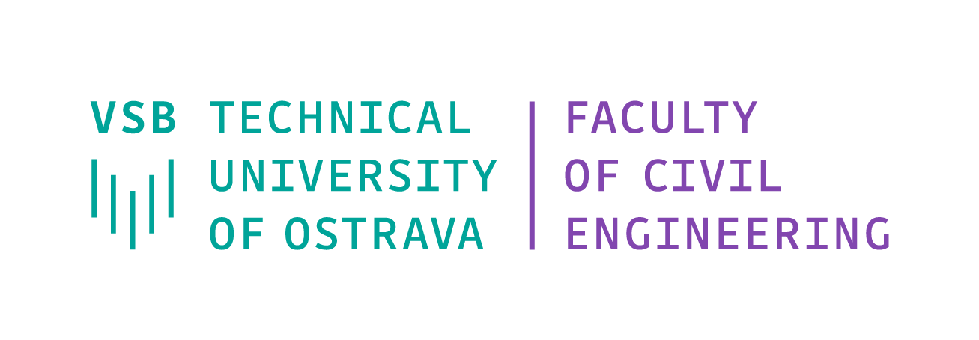
 | Institute of Physics of Materials  Czech Academy of Sciences



