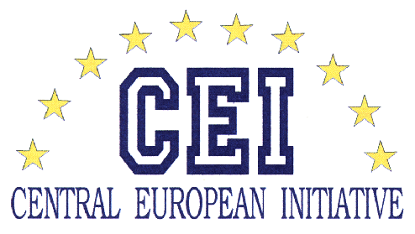

SPRING WORKSHOP FOR YOUNG RESEARCHERS FROM SOUTH-EAST & CENTRAL EUROPEAN COUNTRIES:

“DEVELOPING ENTREPRENEURIAL SKILLS FOR FUTURE CAREER:
CREATING INNOVATION THROUGH RESEARCH BASED ACTIVITIES”
9-17 MAY, POZNAŃ, POLAND

The workshop is addressed to PhD students and young researchers and is focused on providing them with the knowledge on starting up a new business, research funding, project management and science - business cooperation. Such skills are crucial for a successful knowledge transfer (from research into practice) and development of an academic entrepreneurship. The participants will have a great opportunity to undertake this training in a multicultural environment, to share their knowledge and experience, which may result in a future co-operation.

The programme of the workshop is divided into the following modules:
- EU research and innovation opportunities. (2 days)
This part of training will provide participants with the knowledge of Seventh Framework Programme (FP7), especially in the field of mobility opportunities and establishing cooperation among different research institutes.
Trainer: Joanna Bosiack-Kniat, FP7 Regional Contact Point
- II. How to manage research projects on a European scale: techniques and tools. (1 day)
Participants will learn how to draw up a project, how to monitor its progress; what is an effective time planning and financing. It will provide them managerial skills that are necessary for performing on European research market.
Trainer: Cecilia Blasetti, Elettra Synchrotron Light Source.
- III. Workshop on research entrepreneurship: “Kyma” example. (4 days)
This part will be focused on the entrepreneurial skills. Participants will be acquainted with the most important issues of academic entrepreneurship, including starting-up new business, intellectual property rights and creating business plan.
Trainer: Dr. Mauro Zambelli, Elettra Synchrotron Light Source.
The seminars will be held from the 9th to 17th of May 2009 at the Faculty of Physics, Adam Mickiewicz University of Poznań. All the lectures will be given in English.

The project originates from the initiative of the Centre for European Integration at Adam Mickiewicz University and Elettra Synchrotron Light Source, Trieste, Italy.

Coordinator: Joanna Morawska
Agata Zabor

Centre for European Integration
Adam Mickiewicz University
Umultowska 85, 61-614 Poznań, Poland
Phone: +48 61 829 52 91
Fax: +48 61 829 52 90
E-mail: centrum@amu.edu.pl

