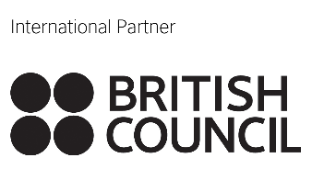
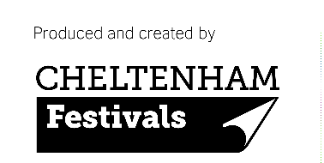

APPLICATION - FAMELAB 2018

Welcome to FameLab!

In the Czech Republic the competition is organised by the British Council under the patronage of the chairwoman of the Czech Academy of Sciences, Professor Eva Zažímalová with support from ADETO z.s., Czech Centres, Tomas Bata Foundation and the British Embassy Prague.
Details about the competition are available at:
www.famelabcz.com a www.britishcouncil.cz
on Facebook: FameLab Czech Republic – Česká republika
and also on Twitter: famelabcz.

Your application will not be shared with the judges or the public.
Personal Details:
Title/s:
Name:
Surame:
Gender: Female Male
Age Group: 21 – 25 26 – 30 31 – 35 36 – 40 41+
Contact Email:
Contact Phone Number:
Address:

Field of Study/Work:
Your Work/Study Role:
University/Employer:

Do you have previous experience of doing science communication?
Yes No Not Sure

How did you find out about FameLab?

Please briefly introduce yourself (hobbies, etc.) – Thiss information will be provided to the host of the competition and will be used to introduce you to the audience prior to your talk.

Information about your presentation:
What scientific subject will you be talking about?

Which regional heat would you prefer to take part in?
1) Praha, 10. 3. 2018 (Saturday)
2) Zlín, 24. 3. 2018 (Saturday)
3) Both dates are possible
All heats will be bilingual (you can choose to give your talk in Czech/Slovak or English). The weekend Masterclass for finalists will be led in English and will take place from 13th to 15th April 2018. Further details regarding the Masterclass will be distributed to finalists after the conclusion of both regional heats.

Please remember that your talk must not be longer than 3 minutes, has to be factually correct and understandable for the wider public (and if possible entertaining).
Please submit your application form to famelabcz@gmail.com by 28. 2. 2018.

By submitting your application you, hereby, give the organisers permission to publish photographs and videos made during the competition.

Videos from previous years of FameLab can be found on our YouTube channel FameLab CZ.

If you have any queries regarding you application or the competition please contact the co-ordinator of FameLab in the Czech Republic, Dasa Sephton, on +420 605 882 555, or dasa.sephton@britishcouncil.cz.

Thank you for your interest in participation in FameLab 2018 and we look forward to working with you!

FameLab Czech Republic Team

The British Council is committed to:

Data protection
British Council and partners only collect and use the personal data for the purposes that have been agreed or are clearly implied by the circumstances. They do not transfer or disclose the personal data to third parties without the consent of the other unless it has already been agreed or is clearly implied by the circumstances.

Child protection
We believe that child protection requires everyone to take responsibility and that every child matters. We recognise that the care, protection and welfare of children is paramount and that all children have the right to be protected from all types of harm. We also recognise that we have a fundamental duty of care towards all children where our programmes and operations facilitate contact with children, or have an impact on children.

Equality and diversity are at the heart of our cultural relations ambitions. They contribute to the mutual trust, respect and understanding we strive for on behalf of the UK. They are integral to our brand, our reputation, our success and are an integral part of our cultural relations impact.

For more information please visit www.britshcouncil.cz

