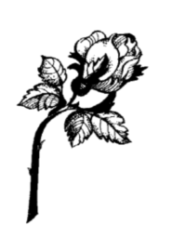
Dream On – Aerosmith, a song I´ve listened to
for over 30 times last few days. A constant
reminder to never stop chasing your dreams,
even if they seem impossible to reach. Never
be afraid of conformity, of society of failure,
of the Impossible.
To all my friends: Dream on, dream on, dream on,
dream till your dreams come true!
Justin Tan

S bolestí v srdci oznamuje všem kamarádům, známým a spolužákům,
že nás navždy opustil/
We are deeply saddened to announce the untimely passing of a very bright soul, whom the entire student body and staff of VŠB – Technical University
of Ostrava is fortunate to have had in our presence.

JUSTIN TAN HONNG TZE,

student of Nanyang Technological University, Singapore,
který zde studoval v rámci výměnného pobytu na Fakultě strojní/
who studied as an exchange student at the Faculty of Mechanical Engineering here.

Svůj boj o život po těžké tragické nehodě prohrál dne 25. 11. 2016.
He passed away after a tragic accident in Slovakia on 25. 11. 2016.

