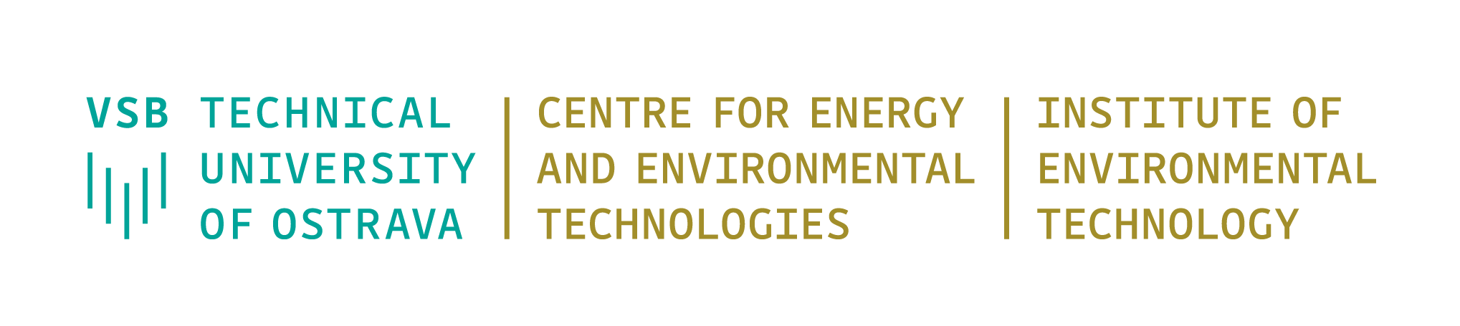

Seminar
‘Step-by-step from agricultural wastes to useful carbon products’

Tuesday 27th September 2022, from 10.00 to 12:00
Meeting room 3.04, Institute of Environmental Technology, CEET, VŠB-Technical University of Ostrava, 17. listopadu 15/2172, 708 000 Ostrava-Poruba
Programme
10:00 – 10:10 – Registration of participants
10:15 –10:15 – Dr. Lenka Matějová
Opening speech and introduction of the guests
10:15 – 11:00 – Dr. Gerardo Cruz (University of Tumbes, Peru)
Talk: Environmental research in the National University of Tumbes
11:00 – 11:30 – John Rimaycuna, MSc. (University of Tumbes, Peru)
Talk: Adsorption of lead using biochar impregnated with ZnO Nanoparticles
11:30 – 12:00 – Scientific discussion, presentation of IET laboratories according to guest requirements
12:00 – Closing of the seminar

Acknowledgement
This seminar is supported from ERDF "Institute of Environmental Technology – Excellent Research" (No. CZ.02.1.01/0.0/0.0/16_019/0000853).

